USDA Foreign Agricultural Service
GAIN Report

Global Agriculture Information Network
Template Version 2.09

Required Report - public distribution
Date: 10/21/2004
GAIN Report Number: BR4016
BR4015
Brazil
Exporter Guide
Annual
2004

Approved by:
Ron Verdonk, Director
U.S.AGRICULTURAL TRADE OFFICER
Prepared by:
Fabiana Fonseca, Agricultural Marketing Specialist

Report Highlights:
This report provides information on procedures related to importing food products in Brazil and also brings to light some characteristics of the major importers and their purchasing criteria.

Includes PSD Changes: No
Includes Trade Matrix: No
Annual Report
Sao Paulo [BR3]
[BR]
I. Market Overview

Brazil will meet its year-end primary budget surplus goal of 4.25 percent of gross domestic product, however, political pressure is building to increase government spending. The high primary surplus, which does not include interest payments on debt and is stipulated in the country’s loan agreement with the International Monetary Fund (IMF), serves as a guarantee to investors that Brazil will continue to pay down its public-sector debt.

The government maintains that the markets would punish any relaxation in fiscal policy, which would be bad for the economy and even worse for the government’s approval ratings. According to the Brazilian Institute of Geography and Statistics (IBGE), the Brazil’s GDP of R$1.514 trillion in 2003 reflected an actual shrinkage of 0.2 percent. The economy has not expanded to its potential and fiscal policies have probably had an even greater dampening effect upon demand, slowing down productive investments and jeopardizing income.

The economy is forecast to grow by 3.5% in 2004, yet economists question whether Brazil will be able to sustain a meaningful expansion. Analysts indicate that the economy is performing in 2004 similarly to 2000’s outcome when GDP appreciated 4.4 percent. Since Brazil is at or above historical highs for industral capacity usage and investments are still relatively limited, the crucial issue now is how the Brazilian Government will overcome inflationary pressure.

That said, as the following table shows, inflation has remained in check, the country continues to run a solid trade surplus and interest rates, though still high by international standards, have declined somewhat.

ECONOMIC INDICATORS

 | 2000 | 2001 | 2002 | 2003 | 2004* | 2005*
GDP Growth (%) | 4.4 | 1.3 | 1.9 | -0.2 | 3.7 | 3.9
Inflation-IPCA (%) | 6.0 | 7.7 | 12.5 | 9.3 | 5.9 | 5.1
Interest Rate-Selic (%) | 16.1 | 19.0 | 25.0 | 16.5 | 15.0 | 14.0
Total Exports (US$ billion) | 55.0 | 58.2 | 60.4 | 73.1 | 80.0 | 85.6
Total Imports (US$billion) | 55.7 | 55.6 | 47.3 | 48.3 | 54.0 | 60.2
Trade Balance (US$billion) | -0.7 | 2.6 | 13.1 | 24.8 | 26.0 | 25.4
Current account (US$billion) | -24.2 | -23.2 | -7.6 | 4.0 | 5.0 | 5.0
Average Exchange Rate (R$-US$) | 1.83 | 2.35 | 3.54 | 2.90 | 2.95 | 3.10
Source: Brazilian Institute of Geography and Statistics (IBGE), Brazilian Central Bank, Secretariat of Foreign Trade (SECEX), Getulio Vargas Foundation (FGV), Research Institute for Applied Economics (IPEA)
* forecast

Since abandoning a fixed exchange rate regime in 1999, the US Dollar has appreciated approximately 40 percent vis-à-vis the Brazilian Real. Various categories of imported agricultural products were affected differently by these economic adjustments. As such, U.S. bulk, intermediate, consumer–oriented, forest, and seafood product exports to Brazil show divergent results.

Brazil’s agricultural system is well developed. The country is the leading exporter of coffee, sugar, orange juice, beef and also ranks among the top producers and exporters of soybeans, corn, poultry, fresh fruit, etc. In consequence, it comes as no surprise that major food multinationals play an active role in the commodity merchandising and food processing business given relatively inexpensive labor and other production costs. At the same time, a domestic market of more than 180 million consumers provides the other main attraction for developing business in Brazil.

On the other hand, Brazil has the most imbalanced income distribution in South America. According to the Brazilian Institute of Geography and Statistics (IBGE), the top ten percent wealthiest individuals own three-fourths of the national wealth. This helps explain why imported consumer-oriented products are more susceptible to exchange rate oscillations. Given the weakening of the Real in the course of this decade, imported products tend to be luxury items, only affordable for a limited percentage of the population, probably at least five million individuals.

For these high-end consumers, importers have to offer what is new, trendy and also a wider variety of products and brands. These market atmospherics make import operations a little more difficult for both Brazilian importers and foreign exporters who prefer to deal in container loads of a single product as opposed to multi-product consolidated cargos.

Given this outlook, there are challenges and advantages to be investigated prior to entering the market, as illustrated below:

ADVANTAGES | CHALLENGES
More supermarkets are showing interest in selling imported goods. | Brazil is self-sufficient in food supply. An imported product is a luxury item and not a necessity. Retailers offer foreign goods to differentiate themselves and develop new niche markets. US exporters may start selling small volumes but in the long run there are possibilities to establish a plant in Brazil.
Price is not always the determinant purchase criteria for high-end consumers. | High-end consumers are more demanding regarding other aspects of products such as innovation, packaging, status, new trends, etc.
The US food industry is able to respond to consumers’ demand promptly, regardless of the segment of products. | Brazilian consumers/importers have limited trade relations with the US. There is room to develop.
As a developing economy, Brazil still is very sensitive to international turbulence in addition to its own internal issues. | Learn how to operate in an up-and-down environment where long-term planning is not easy to implement or predict.

II. Exporter Business Tips

When exporting to Brazil, U.S. companies need to understand that the import process is heavily influenced by the Government of Brazil (GoB) through its decrees and procedures, which are implemented by different branches of the federal government to regulate the various aspects of trade between Brazil and other countries. The GoB has modified Brazil’s one aspect or another of foreign trade regulations within short periods that can catch companies involved in import-export off-guard, so Brazilian importers need to keep abreast of changes in standards and decrees.

Not infrequently, new-to-market U.S. suppliers have found local importers especially demanding and determined documentation requested not truly necessary. Of course, when exporters provide the right documentation to their Brazilian importers, the import transaction concludes more quickly, facilitating the business relationship between buyer and seller. To explain the import process, the system is described below. The main Brazilian Government offices involved in import administration, including tariff collection, are:

Ministry of Finance (MF)
Main divisions:
> Secretariat of Federal Revenue (SRF)
> Brazilian Terminology Committee (CBN)
> National Monetary Council (CMN)
> Brazilian Central Bank (BC)

Ministry of Development, Industry and Foreign Trade (MDIC)
Main division:
> Secretariat of Foreign Trade (SECEX)

For imports of agricultural food products, the following Brazilian Government offices can play a role in the clearance process depending on the product:

Ministry of Agriculture, Livestock and Food Supply (MAPA)
In general, MAPA is the primary ministry overseeing and enforcing most of the regulations regarding production, import, export, sanitary and phytosanitary issues for bulk commodities, meats, dairy and fishery products, beverages, feed/fodders, pet food, seeds, plants, fruits and vegetables. U.S. products of animal origin (beef, pork, seafood, and dairy and processed poultry) are allowed into the Brazilian market, if the product comes from a U.S. federally inspected plant, which has the approval of the Brazilian Animal Products Origin Inspection Service (DIPOA). Unprocessed products of plant origin (fruits, seeds, and grains) can be exported to Brazil after the Brazilian Plant Health and Inspection Service (DDIV) completes a pest risk analysis of the product, and if accompanied by USDA/APHIS/PPQ phytosanitary certificate.

Ministry of Health (MS)
Through ANVISA, an agency created in 1999, MS enforces regulations regarding processed food products, tobacco and tobacco products. The primary function of this agency is to safeguard public health; therefore, all food products marketed in Brazil are under ANVISA’s purview.

For additional information on GoB regulations regarding imports of agricultural commodities and food products from the United States, such as labeling requirements, including products containing biotech ingredients, please check the "Food and Agricultural Import Regulations and Standards" (FAIRS) report, number BR4616, dated July 28, 2004 at the USDA/FAS home page, “www.fas.usda.gov” or on the USDA Brazil home page “www.usdabrazil.org.br”.

Since January 1997, the Secretariat of Foreign Trade (SECEX), the Secretariat of Federal Revenue (SRF) and the Brazilian Central Bank (BC) have been responsible for import related activities such as licensing, customs clearance and exchange monitoring though the Integrated Foreign Trade System (SISCOMEX), an administrative software program with graphic interface to complete the computer-based import document. Since this system has been implemented, import and export procedures have become more transparent, allowing the GoB to adopt quick measures to minimize trade deficits and frauds. The system also enables the government to better control tax payments.

Brazilian companies interested in importing must register with the Importers and Exporters Registry Office of SECEX. Registrations completed prior to 1997 have been entered into the SISCOMEX. New registrants are automatically added to the system upon the first import transaction. It is necessary to be registered at the SRF in order to obtain a user password to access the SISCOMEX.

Brazilian importers may contact foreign manufacturers, trading companies, concessionaires or any individual interested in exporting to Brazil to determine products of interest for importation, as well as cost, guarantees, type of payment, etc. Such contact may be done via fax, e-mail, by telephone or personally. The importer must then request from the foreign exporter the remittance of a document that formalizes the transaction costs agreed upon (pro forma invoices, letters, telegrams, fax, purchase orders or contracts). At any given time, SECEX may request relevant information or documentation on the transaction from the importer. In case of discrepancies, SRF may arbitrate the product value in order to establish the applicable tariff rate.

Another important element is the means used to ship the product, as well as whether payment of the freight is the importer or exporter’s responsibility. If the exporter pays the freight charges, the bill of lading will highlight that freight is "pre-paid". If the importer is paying for the freight charges, the bill of lading will include information that the freight is "collect".

The Import License (LI) can be either automatic or non-automatic and is executed through the SISCOMEX. In order to grant a license, the SISCOMEX will require information regarding commercial, financial, tax and exchange details of the transactions to define the legal status.

> Automatic Licensing: products not subject to special control or special conditions will be automatically licensed upon completion of the Import Declaration of Customs Clearance in the SISCOMEX system.
> Non-Automatic Licensing: products or transactions subject to special importation approval or which are required to comply with special conditions must obtain licensing prior to shipment or before registering the Import Declaration. A list of products and/or transactions, as well as the schedule for licensing, according to general conditions of trade, may be found in the SISCOMEX Administrative Treatment chart.

Generally speaking, agricultural products fall into the latter of the two licensing protocols, which means that they can only be exported to Brazil after MAPA or MS approval. This special authorization is requested and released by the system. Importers, however, may want to contact the pertinent ministry to speed up the process in case more documentation or analysis is needed. In general, the authorization is granted within a week.

Once the commercial transaction is concluded, the importer may authorize shipment of the merchandise to Brazil. Products and/or transactions subject to prior import approval must have obtained the approval prior to shipment. After shipping, the exporter must send, according to the established method of payment, the documentation that will allow the importer to gain release of goods from Brazilian Customs.

Documentation required:
> Shipping information (B/L or AWB)
> Commercial invoice
> Certificate of origin (for International Agreement products)
> Phytosanitary certificate (when required by Brazilian law)

Overseas payment may be done in advance, by collection or by letter of credit (cash or installments). A Foreign Exchange Contract, according to the standards and regulations established by the Brazilian Central Bank, formalizes the buying and selling of foreign currency between the importer and an authorized exchange establishment. For simplified exchange transactions, transactions made through DSI, up to the value of US$10,000, or the equivalent in other currency, the formalization of the exchange can be made with a signed docket. The exchange transactions may be made for immediate or delayed payment. The time between signing the contract and payment of the transactions must not exceed 360 days. When the payment is made before Customs clearance the bond between the Import Declaration and the Foreign Exchange Contract will be established according to the form of payment agreed upon by the importer, or according to the negotiating bank upon exchange settlement.

The clearance process starts when imported products arrive in Brazil. The importer or a contracted customs broker, using relevant documentation, LI (if necessary), shipping information, commercial invoice, and other documents required due to special characteristics of the product and/or transaction, will prepare the Import Declaration (DI) in the SISCOMEX and, upon payment of the Import Tax, Excise Tax (IPI also known as Tax on Manufacture) and SISCOMEX user fees, will register the DI. This starts the customs clearance process.

Clearance from Customs consists of a series of acts carried out by a Customs official who will authorize the release of the goods to the importer after the verification of the merchandise, verification of compliance with tax laws and of the importer’s identity. The SRF will release an Import Warrant (CI) via SISCOMEX that will confirm Customs clearance. SISCOMEX will then automatically select the method of Customs clearance:

> Green: customs clearance authorization is automatically issued.
> Yellow: mandatory inspection of documentation is required and, if no evidence of irregularities is found, customs clearance authorization is issued.
> Red: mandatory inspection of documentation and of merchandise is required before customs clearance authorization is issued.
> Gray: mandatory inspection of documentation, merchandise, and the taxable basis of Import Tax is required before customs clearance authorization is issued. Customs clearance authorization can be arranged before the conclusion of the inspection of customs value, by using a guarantee issued by the importer.

Except for the green option, all documents, together with the receipt of the Import Declaration printed by SISCOMEX and proof of payment or waiver of the ICMS (Value-Added Tax also known as Interstate Movement Tax on Sales and Services), should be presented by the importer to the Federal Revenue Office where the goods are located for the conclusion of the customs clearance. For goods assigned the gray option, a Declaration of Customs Value (DVA) must be made and transmitted via SISCOMEX to explain the commercial aspects of the transaction and to provide additional information to justify the value. Any corrections to the information presented in the DI, changes in the calculation and additional tax or fines required by law, will be carried out in accordance with SISCOMEX procedures.

III. Market Sector Structure and Trends

Imported consumer-oriented products are distributed in the Brazilian market mainly through retailers and specialized importers. Major retailers are willing to import directly in order to obtain better margins. However, when volumes do not reach an advantageous level in financial terms, retailers buy from local importers/distributors. While avoiding the middleman is a general goal, it only happens if retailers are able to fill containers and keep overhead costs in check. The most preferable for them option is mixed containers.

As a result of the lack of economic growth in 2003, consumers lost purchasing power; hence Brazil’s local retail industry also registered negative results. The sector’s gross sales were valued at R$87.2 billion in 2003, which represented 9.3 percent growth in nominal terms compared to the previous year, however, applying the IPCA deflator it showed a depreciation of 4.7 percent, cutting revenues to R$76.01 billion. According to the Brazilian Institute of Geography and Statistics (IBGE), the sector accounted for 5.8 percent of GDP, the sum total of which was R$1.514 trillion (for detailed information on the Brazilian retail industry, please refer to the Retail Food Sector report, number BR4014, dated August 4, 2004 which can be found at the USDA/FAS home page or at the USDA Brazil home page).

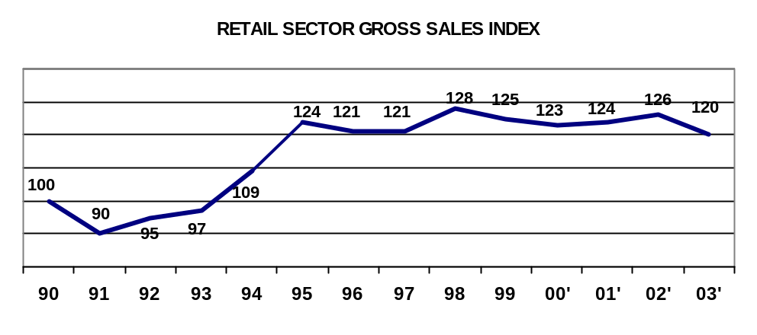
Source: ABRAS/ACNielsen

MAJOR 10 RETAIL COMPANIES IN 2003

RETAILER NAME | OWNERSHIP | SALES  (R$ MIL) | SHARE | No. of OUTLETS | LOCATION | PURCHASING AGENT TYPE
1- Cia. Brasileira  De Distribuicao  (Pao de Acucar, Extra, Se, Compre Bem) | Brazil/France | 12,788 | 14.6 | 497 | South  Southeast  Center-East  Northeast | LFP, DI, LI
2- Carrefour  (Carrefour, Champion, Dia Brasil) | France | 11,028 | 12.6 | 329 | South  Southeast  Center-East  North  Northeast | LFP, DI, LI
3- Sonae  (Big, Mercadorama, Nacional, Maxxi) | Portugal | 3,732 | 4.2 | 148 | South  Southeast | LFP, DI, LI
4- Bompreco*  (Bompreco, Balaio) | Netherlands | 3,442 | 3.9 | 118 | Northeast | LFP, DI, LI
5- Sendas** | Brazil | 2,273 | 2.6 | 76 | Southeast | LFP, DI, LI
TOTAL TOP 5 |  | 33,264 | 37.9 | 1,168
6- Wal-Mart  (Wal-Mart, Todo Dia, Sam’s Club) | US | 1,940 | 2.2 | 25 | South  Southeast | LFP, DI, LI
7- Cia. Zaffari | Brazil | 1,182 | 1.4 | 26 | South | LFP, DI, LI
8- Coop | Brazil | 940 | 1.1 | 21 | Southeast | LFP, DI, LI
9- G. Barbosa | Netherlands | 923 | 1.1 | 32 | Northeast | LFP, DI, LI
10- Irmaos Bretas | Brazil | 811 | 0.9 | 40 | Center-East | LFP, DI, LI
TOTAL TOP 10 |  | 39,062 | 44.6 | 1,312
Note: LFP (local food processors), DI (direct imports), LI (local importers). Note: * Bompreco was acquired by Wal-Mart from Ahold in March 2004 and **Sendas became an associate chain of Cia. Brasileira De Distribuicao
Source: ABRAS/ACNielsen
Overall sales of the Brazilian food processing industry totaled R$157.9 billion in 2003, which represented 21 percent growth in nominal terms compared to the previous year. The local food processing industry tends to negotiate directly with foreign suppliers as their purchases are more specific, however, few importers of ingredients are present in the market (for detailed information on the Brazilian processing industry, please refer to the Food Processing Ingredients Sector report, number BR4003, dated April 6, 2004 at the USDA/FAS home page or at the USDA Brazil home page).

FOOD PROCESSING SECTOR TRADE BALANCE (R$ billion)

 | 1998 | 1999 | 2000 | 2001 | 2002 | 2003
Production | 85.8 | 92.3 | 136.5 | 112.1 | 130.5 | 157.9
Exports | 10 | 15.6 | 14.1 | 23.7 | 31.2 | 40.7
Imports | 2.5 | 2.9 | 2.7 | 2.6 | 3.5 | 3.2
Domestic Consumption | 78.3 | 79.6 | 125.1 | 91.0 | 102.8 | 120.4
Source: Brazilian Food Processors’ Association (ABIA)

The majority of imported consumer-oriented products found in Brazil today are sourced from Mercosul suppliers, as trade among countries of this economic bloc is duty-free. Products shipped by member countries are price competitive with local products or at least not price-prohibitive. The European Union is the second largest player in the market, aggressively promoting its premium products and targeting high-end consumers. With the advantage that Brazilian upper-class eating habits are strongly influenced by European tastes, EU products are naturally viewed as being traditional and sophisticated. As a result, EU-origin products are often viewed as being preferred within several high-end product categories. The EU is a direct competitor for US products. However, despite the EU’s favorable position, U.S. companies are able to offer the same standards of products that EU suppliers do and can increase market share in the Brazilian market.

BRAZIL’S IMPORTS OF CONSUMER-ORIENTED PRODUCTS (US$ million)

 | 2000 | Share (%) | 2001 | Share (%) | 2002 | Share (%) | 2003 | Share (%)
Mercosul | 1,003.9 | 63.5 | 635.5 | 55.6 | 649.7 | 58.5 | 602.9 | 60.6
EU | 303.7 | 19.2 | 263.9 | 23.1 | 232.7 | 21.0 | 205.0 | 20.6
U.S. | 104.3 | 6.6 | 92.1 | 8.0 | 82.6 | 7.4 | 72.4 | 7.3
Others | 168.4 | 10.7 | 151.7 | 13.3 | 145.3 | 13.1 | 114.6 | 11.5
Total | 1,580.3 | 100.0 | 1,143.2 | 100.0 | 1,110.3 | 100.0 | 994.9 | 100.0
Source: Brazilian Secretariat of Foreign Trade (SECEX)

In 1994 with the implementation of the Real Plan and through the rest of the last decade, imported products became a true alternative to domestically produced goods and for this reason the retail industry has gained power vis-à-vis domestic food processors. Even though imported products represent significantly less than five percent of retail sales today, arguably local food processors do not possess control over product supply and pricing commensurate with their market share when negotiating with retailers. Retailers are well aware of their importance in the food distribution system, exerting considerable purchasing power and reaching the overwhelming majority of Brazilian households. Approximately 80 percent of food distribution takes place through retail stores.

Food Distribution
Local
Demand
Export
Grower
Wholesaler
Import
Retail
Import
Wholesale
Import
Food Service
Import
Local
Demand
Export
Food
Industry
Import
Retail
Import
Wholesale
Import
Food Service
Import
In Natura
Processed
Ag GDP

IV. Best High-Value Product Prospects

A. Products present in the market which have good sales potential
According to ACNielsen, from 1994 to 2003 product categories indicating the most significant growth in volume are the following: fruit juices (1263 percent), cake mixes (582 percent), aseptic milk (552 percent), dog food (410 percent), spirits/sport drinks (378 percent), cappuccino (372 percent), meat cuts/cold (348 percent), flavored milk (340 percent), cakes (334 percent), ready to serve desserts (309 percent), instant pasta (286 percent), breakfast cereals (272 percent) and cat food (243 percent).

Focusing on imports, products representing good sales potential are those that in their original market also target high-end consumers or are well known brands. In addition, Brazilian importers/distributors usually prefer products of six months shelf life or more. The segments of the population that can buy imported products regularly are estimated in 5-8 million individuals. For this audience, in addition to the product itself, its packaging, status, level of innovation, etc are important attributes. Products that combine these characteristics are more likely to successfully enter the market.

According to ATO analysis, in the past five years, consumer-oriented food product categories that have demonstrated the best performance in the market are: snack foods, wine/beer, fruit/vegetable/nuts (fresh/processed), dairy products, red meats (prepared/preserved), pet foods (dog/cat food) and seafood products.

B. Products not present in significant quantity but which have good sales potential
Health foods, especially natural and organic products, have a limited presence in the Brazilian market. The Brazilian food industry has not made significant investments to develop these segments, as the consumer base is restricted to a slice of the Brazilian population, which is therefore less attractive when considering return on investment. There are limited suppliers in the market for these products and consequently prices are high to prohibitive. Small and medium-sized companies are responsible for 70 percent of local organic supply. According to the Institute of Biodynamics (IBD), sales of organic items are expanding rapidly, on average 40 percent/year. In the local market, prices of health foods, organic and natural products compared to conventional products are 40 to 300 percent higher. As the US industry for this segment has already achieved gains in scale and prices for these products are relatively closer in the U.S. market to those of conventional equivalents, exporters can find opportunities in the Brazilian market. This is because the price of the imported product could still be lower compared to locally produced ones, regardless of the current exchange rate.

C. Products not present because of significant trade barriers
Brazilian legislation requires all food items to be approved by Ministry of Health (MS) or Ministry of Agriculture, Livestock, and Food Supply (MAPA) prior to shipment. In general, there are no barriers towards importation of food products; nevertheless, there are procedures to be followed. Currently, unprocessed poultry product imports are banned (Brazil does not allow the entry of this item per reciprocity), and for products containing ingredients derived from biotech commodities there are also considerable restrictions.

V. Key Contacts and Further Information

Please do not hesitate to contact the USDA/FAS offices below for questions or comments regarding this report or require assistance to export processed food products into Brazil:

Office of Agricultural Affairs (OAA) Agricultural Trade Office (ATO)
American Embassy, Brasilia Rua Henri Dummont, 700
Av. das Nacoes, Quadra 801, lote 3 01418-200 Sao Paulo, SP
70403-900 Brasilia, DF Phone: (55-11) 5186-7400
Phone: (55-61) 312-7101 Fax: (55-11) 5186-7499
Fax: (55-61) 312-7659 E-mail: Atobrazil@usdabrazil.org.br
Agbrasilia@fas.usda.gov http://www.usdabrazil.org.br

Other information sources include:
A. Government Regulatory Agencies:
Office of Agricultural Protection (SDA) Brazilian Environment Institute (IBAMA)
Ministry of Agriculture, Livestock, and Food SAIN - Av. L 4 Norte
Supply (MAPA) 70800-200 Brasilia, DF
Esplanada dos Ministerios, Bloco D Phone: (55-61) 226-8221
Anexo B, 4 Andar, Sala 406 Fax: 322-1058
Brasilia, DF 70043-900 Internet site: http://www.ibama.gov.br
Phone: (55-61)218-2314/15
FAX: (55-61) 224-3996 or 218-2316
Interne site: http://www.agricultura.gov.br

Office of Rural Development and
Cooperativism (SARC) Ministry of Science & Tecnology (MCT)
Ministry of Agriculture, Livestock, and Esplanada dos Ministerios, Bloco E
and Food Supply (MAPA) 70067-900 Brasilia, DF
Esplanada dos Ministerios, Bloco D, 3 Andar Phone: (55-61) 321-8886
Sala 304 Fax: (55-61) 225-7496
Brasilia, DF 70043-900 Internet site: http://www.mct.gov.br
Phone: (55-61) 321-3594
Fax: (55-61) 321-4524
Internet site: http://www.agricultura.gov.br

Agency of Sanitary Surveillance (ANVISA) Ministry of Justice
Ministry of Health Esplanada dos Ministerios, Bloco T
Esplanada dos Ministerios, Bloco G 70064-900 Brasilia, DF
70058-900 Brasilia, DF Phone: (55-11) 224-0954
Phone: (55-61) 315-2343 Fax: (55-61) 322-6817
Fax: (55-61) 225-6056 Internet site: http://www.mj.gov.br
Internet site: http://www.saude.gov.br

Ministry of Development, Industry and Brazilian Customs (Receita Federal)
Foreign Trade (MDIC) Ministry of Finance
Esplanada dos Ministerios, Bloco J Esplanada dos Ministerios, Bloco P
70056-900 Brasilia, DF 70048-900 Brasilia, DF
Phone: (55-61) 329-7000 Phone: (55-61) 412-3000
Fax: (55-61) 329-7230 Fax: (55-61) 412-1721
Internet site: http://www.mdic.gov.br Internet site: http://www.fazenda.gov.br

B. Trade Association:
Brazilian Association of Supermarkets (ABRAS) Brazilian Assoc. of Food Industries (ABIA)
Av. Diogenes Ribeiro de Lima, 2872 Av. Brigadeiro Faria Lima, 2003, 11 Andar
05083-901 Sao Paulo, SP 01451-001 Sao Paulo, SP
Phone: (55-11) 838-4500 Phone: (55-11) 814-6688
Fax: (55-11) 837-9933 Fax: (55-11) 814-6688
Internet site: http://www.abrasnet.com.br Internet site: http://www.abia.com.br

Brazilian Association of Exporter and Importer
of Food And Beverage (ABBA)
R. Machado Bittencourt, 190 - cj. 609
04044-000 Sao Paulo, SP
Phone: (55-11) 5087-9546
Fax: (55-11) 55 11 5087-9546
Internet site: www.aabba.org.br

APPENDIX I. STATISTICS

TABLE A. Key Trade & Demographic Information

Agricultural Imports From All Countries ($Mil) / U.S. Market Share (%) | 3,664 / 10.0 % ¹
Consumer Food Imports From All Countries ($Mil) / U.S. Market Share (%) | 839 / 6.0 % ¹
Edible Fishery Imports From All Countries ($Mil) / U.S. Market Share (%) | 203 / 1.0 % ¹
Total Population (Mil) / Annual Growth Rate (%) ² | 170 / 1.82 % ³
Urban Population (Mil) / Annual Growth Rate (%) ² | 138 / 2.7 % ³
Number of Major Metropolitan Areas ² | 9 ⁴
Size of the Middle Class (Mil) / Growth Rate (%) ⁷ | 20 / NA
Per Capita Gross Domestic Product (U.S. Dollars) ² | 2,953
Unemployment Rate (%) ² | 9.7 % ⁵
Per Capita Food Expenditures (U.S. Dollars) ⁶ | 291
Percent of Female Population Employed ² | 41.4 % ⁵
Exchange Rate (US$1=R$ local currency) | 2.90
¹ Source: United Nations Statistical Office – 2003
² Source: Brazilian Geography and Statistics Institutes (IBGE)
³ IBGE Census 2000, total population is estimated in 176.9 Millions for 2003
⁴ Metropolitan areas used for the 2003 Consumer Expenditure Survey - (POF, IBGE)
⁵ 2003 National Household Sample Survey (PNAD, IBGE)
⁶ Value based on the annual average expenditures according to the 2003 Consumer Expenditure Survey - (POF, IBGE)
⁷ Middle class represents 13.8% of the total population with income between R$ 750 and R$ 4,800 per month

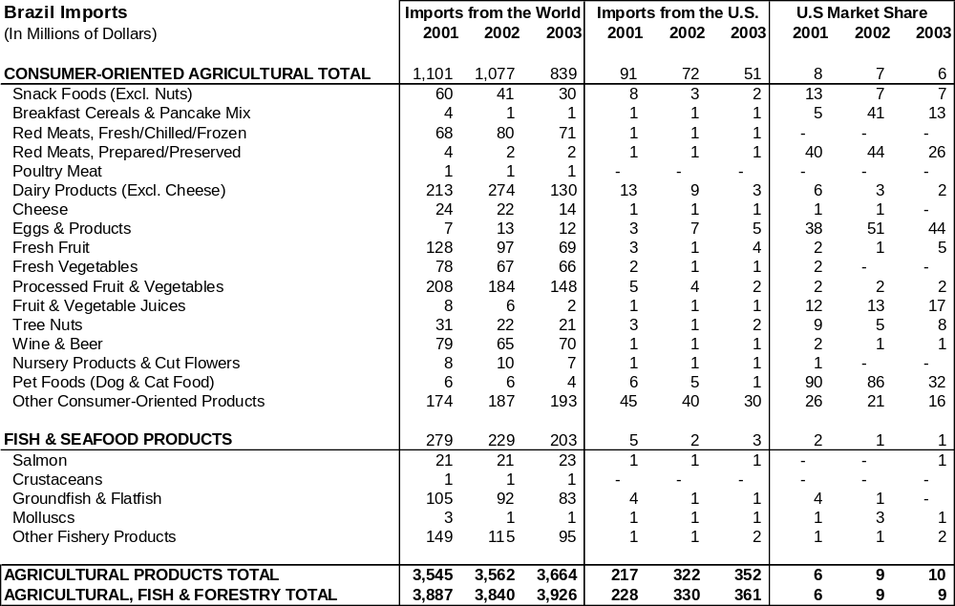
Table B. Consumer Food & Edible Fishery Products Imports

Source: FAS' Global Agricultural Trade System using data from the United Nations Statistical Office

TABLE C. Suppliers of Consumer Food & Edible Fishery Products
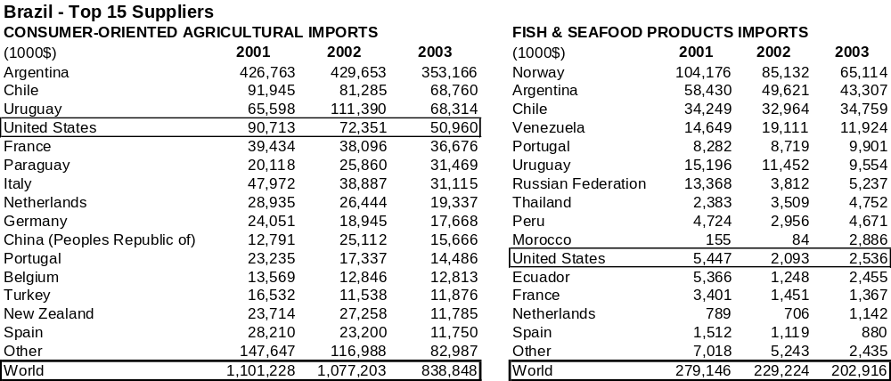

Source: FAS' Global Agricultural Trade System using data from the United Nations Statistical Office

